The Great O Antiphons of Advent
During the last days of Advent, the anticipation of the arrival of our Newborn Savior heightens, and one of the ways this is expressed in the Liturgy is through the "Great O Antiphons." The "O Antiphons" accompany the Magnificat of Vespers (Evening Prayer), and are also paraphrased in the Alleluia verse for each daily Mass.
Each antiphon invokes Jesus using one of the titles of the Messiah and together the antiphons form the verses of the Advent hymn "O Come, O Come Emmanuel."
The titles are arranged in such a way that by taking the first letter of each title in Latin and going in reverse order (Emmanuel, Rex, Oriens, Clavis, Radix, Adonai, Sapientia) the words "ero cras" are formed. This phrase is Latin for "I am coming tomorrow."
- December 17: O Sapientia (O Wisdom)
- December 18: O Adonai (O Lord)
- December 19: O Radix Jesse (O Root of Jesse)
- December 20: O Clavis David (O Key of David)
- December 21: O Oriens (O Dayspring)
- December 22: O Rex Gentium (O King of the nations)
- December 23: O Emmanuel (O With Us is God)

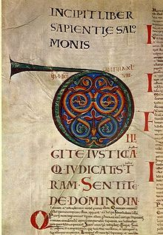
December 17 - O Sapientia
"O Wisdom that comest out of the mouth of the Most High, that reachest from one end to another, and orderest all thing mightily and sweetly, come to teach us the way of prudence!"
Indeed, Wisdom reaches from end to end mightily and governs all things well. Wis. 8:1
The spirit of the LORD shall rest upon him: a spirit of wisdom and of understanding, A spirit of counsel and of strength, a spirit of knowledge and of fear of the LORD, and his delight shall be the fear of the LORD. Is. 11:2-3
This too comes from the LORD of hosts; wonderful is his counsel and great his wisdom. Is. 28:29
These Scripture passages from the Old Testament point out wisdom as one of the great attributes of God, and Christ, as the Word (Jn. 1) sent by the Father does indeed come to teach us the way of prudence. St. Thomas calls prudence "right reason in action," (STh II-II,47,2), and prudence is also frequently referred to as the "mother of all virtues." Since Christ became incarnate in order to be our model of holiness (CCC 459), let us implore Christ, in these last days before Christmas, to gave us the grace to grow in wisdom and prudence, according to the example He has given us.

December 18 - O Adonai
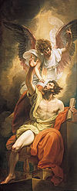
O Lord and Ruler of the house of Israel, Who didst appear unto Moses in the burning bush, and gavest him the law in Sinai, come to redeem us with an outstretched arm.
There an angel of the LORD appeared to him in fire flaming out of a bush. As he looked on, he was surprised to see that the bush, though on fire, was not consumed. So Moses decided, "I must go over to look at this remarkable sight, and see why the bush is not burned." Is. 3:2
For I brought you up from the land of Egypt, from the place of slavery I released you; and I sent before you Moses, Aaron, and Miriam. Mic. 6:4
Indeed the LORD will be there with us, majestic; yes, the LORD our judge, the LORD our lawgiver, the LORD our king, he it is who will save us. Is. 33:22
The title "Adonai," was originally used by the Israelites instead of pronouncing the name of God as revealed to Moses at the burning bush. Not only did God tell Moses His name, but He also gave him the Law, which paradoxically sets us free. Although our culture tells us that freedom is for doing whatever we like, our faith tells us that we have been given a free will so that we might be free to choose the good. The outstretched arm with which Christ comes to redeem us is a merciful arm reaching out to grasp us by the hand, so that we may follow Him with greater love and fidelity to His Commandments, especially in loving God and our neighbor. May our celebration of the birth of Jesus, Emmanuel, God-is-with-us, bring us the grace to allow Him to be Lord of our lives.

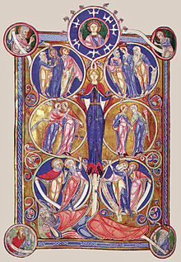
December 19 - O Radix Jesse
O Root of Jesse, which standest for an ensign of the people, at Whom the kings shall shut their mouths, Whom the Gentiles shall seek, come to deliver us, do not tarry.
But a shoot shall sprout from the stump of Jesse, and from his roots a bud shall blossom. Is. 11:1
On that day, the root of Jesse, set up as a signal for the nations, the Gentiles shall seek out, for his dwelling shall be glorious. Is. 11:10
And again Isaiah says: "The root of Jesse shall come, raised up to rule the Gentiles; in him shall the Gentiles hope." Rom. 15:12
Christ, the Root of Jesse, is indeed a sign for all nations, but He does not come as was expected. As a root is humble in its beginnings, hidden in the earth, so Our Lord came hidden in the womb of the Blessed Virgin Mary, and hidden for the first thirty years in the humble family of a carpenter at Nazareth. Even when He began His public ministry, He did not come as a conquering political leader, as many expected of the Messaiah. No, he tells us, "learn from Me, for I am meek and humble of heart." His glorious sign that is set up for all the nations is the Cross on Calvary, bearing the Body of the One who gave Himself up entirely for us, even to the last drop of His Precious Blood. As we beg Him to come without delay to deliver us, may we be granted the grace to be humbly obedient to the will of the Father, just as He was.

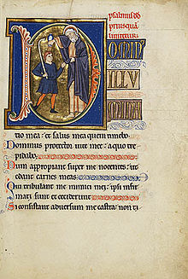
December 20 - O Clavis
O Key of David, and Sceptre of the house of Israel, that openeth and no man shutteth, and shutteth and no man openeth, come to liberate the prisoner from the prison, and them that sit in darkness, and in the shadow of death.
I will place the key of the House of David on his shoulder; when he opens, no one shall shut, when he shuts, no one shall open. Is. 22:22
The people who sit in darkness have seen a great light, on those dwelling in a land overshadowed by death light has arisen. Mt. 4:16
"I will give you the keys to the kingdom of heaven. Whatever you bind on earth shall be bound in heaven; and whatever you loose on earth shall be loosed in heaven." Mt. 16:19
To the angel of the church in Philadelphia, write this: " 'The holy one, the true, who holds the key of David, who opens and no one shall close, who closes and no one shall open'" Rev. 3:7
The Israelites longing for the Messaiah truly did sit in darkness, waiting for their salvation, because the saving grace of Jesus Christ had not yet entered the world. When the Catechism gives us the four reasons for the Incarnation (CCC 457-460), the first reason given is that the Word became flesh "in order to save us by reconciling us with God." Without the Passion, Death, and Resurrection of Jesus Christ, there would be no forgiveness of sins, so He truly is the "Key of David" who opens the gates of Heaven for us. Although the light of Christ has entered our world, we are still like the Israelites, to the extent that we are held captive by our sins, and imprisoned by our vices, whether large or small. In Christ alone will we find true liberty, and He gives us this tremendous gift in the sacraments, above all in Reconciliation. May we receive the grace to recognize Christ as the great liberator, who comes to our prison cells, opens the doors, and leads us out to freedom.

December 21 - O Oriens
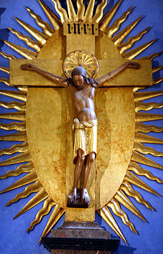
O Dayspring, Brightness of the everlasting light, Son of justice, come to give light to them that sit in darkness and in the shadow of death!
The people who walked in darkness have seen a great light; upon those who dwelt in the land of gloom a light has shone. Is. 9:1
What came to be through him was life, and this life was the light of the human race; the light shines in the darkness, and the darkness has not overcome it. Jn. 1:3-5
"I, Jesus, sent my angel to give you this testimony for the churches. I am the root and offspring of David, the bright morning star." Rev. 22:16
In the tender compassion of our God, the dawn from on high shall break upon us, to shine on those who dwell in darkness and the shadow of death, and to guide our feet into the way of peace.
Lk. 1:78-79
Jesus spoke to them again, saying, "I am the light of the world. Whoever follows me will not walk in darkness, but will have the light of life." Jn. 8:12
Today, on the shortest day of the year, the liturgy calls Christ the Dayspring, the Radiant Dawn. He truly is the Light which comes bursting into our darkness and shows us the way of holiness and peace. And while He calls Himself the light of the world, He also tells us that in him we are the light of the world. We receive this light at Baptism, when the candle is lit from the Easter candle, and the celebrant states, "Receive the light of Christ." Our vocation as disciples of Christ is to spread this light to the world, to allow the brilliant light of Christ's love to shine through us so that those who have not yet been enlightened will come to know His love and forgiveness. Of course, in order to spread that light to others, we must be open to receiving it ourselves, and we must strive to live a life of virtue and grace. Christmas is often called a season of light, so as we gaze upon the beautiful lights all around us, may they serve as a reminder to us that we, too, are called to shine with the light of Christ. May He grant us the grace to receive His light ever more intensely, so that we may help to bring Christ's light to the world, just as Our Lady did, when the Star of Bethlehem shone down.

December 22 - O Rex Gentium
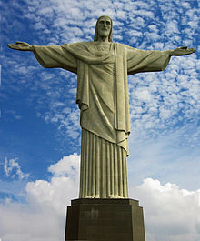
O King of the Gentiles, yea, and desire thereof! O Corner-stone, that makest of two one, come to save man, whom Thou hast made out of the dust of the earth!
God is king over all the earth; sing hymns of praise. Ps. 47:8
Who would not fear you, King of the nations, for it is your due! Among all the wisest of the nations, and in all their domain, there is none like you. Jer. 10:7
And again Isaiah says: "The root of Jesse shall come, raised up to rule the Gentiles; in him shall the Gentiles hope." Rom. 15:12
For he is our peace, he who made both one and broke down the dividing wall of enmity, through his flesh. Eph. 2:14
St. Augustine gave us perhaps the best description of Jesus Christ as the desire of all human hearts when he penned his famous phrase, "our hearts are restless until they rest in Thee." We all experience many different desires, but ultimately these desires point us to God. We feel a lack when we are not filled with God, because He has intentionally created us to long for Him. Unfortunately, it is not always clear to us that He alone will satisfy those many longings, so we try to fill that emptiness with a host of other things. The malls, the retailers, the advertisers - they all want to convince us that their products will fill the spaces in our hearts, and in the hearts of our loved ones, when in reality, only God can do that. The Baltimore Catechism asks the question, "Why did God make you?" and the answer, while straightforward, is also profound: He made us to know Him, to love Him, and to serve Him in this life, and to be happy with Him forever in the next. He is our beginning and our end - we were literally made for Him, and our greatest happiness will be found in loving Him. Of course, He cannot force us to love Him; in fact He gave us a free will so that it is entirely our choice. But then He chose to come to us as an Infant, because it is easy to love infants. May He grant us the grace this Christmas to lay down our hearts and our very lives in adoration before our Newborn King, who holds out a hand to each of us, inviting us to allow Him to satisfy the desires of our hearts.

December 23 - O Emmanuel
O Emmanuel, our King and our Law-giver, Longing of the Gentiles, yea, and salvation thereof, come to save us, O Lord our God!
Therefore the Lord himself will give you this sign: the virgin shall be with child, and bear a son, and shall name him Immanuel. Is. 7:14
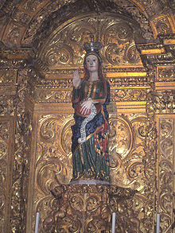
"Behold, the virgin shall be with child and bear a son, and they shall name him Emmanuel," which means "God is with us." Mt. 1:23
Jesus said to them, "I am the bread of life; whoever comes to me will never hunger, and whoever believes in me will never thirst...Your ancestors ate the manna in the desert, but they died; this is the bread that comes down from heaven so that one may eat it and not die. I am the living bread that came down from heaven; whoever eats this bread will live forever; and the bread that I will give is my flesh for the life of the world." Jn. 6:35, 49-51
God has always been with us, but the Incarnation radically changed His manner of being "with us." The most sacred item for the people of the Old Testament was the Ark of the Covenant, which contained several holy objects: the stone tablets of the Ten Commandments, God's word inscribed by God Himself; a jar of the manna with which God fed them in the desert; and Aaron's rod, the symbol of his priesthood (Heb. 9:4). From the moment of the Incarnation, when the Holy Spirit overshadowed the Blessed Virgin Mary, who is called the Ark of the New Covenant, she held within her womb the Word of God in the flesh, who is the true manna in the Most Holy Eucharist, and who is the Eternal High Priest. Emmanuel, "God with us," loves us with an intensity that is beyond our human comprehension, but we can begin to grasp it when we approach Him in the Blessed Sacrament, and receive Him into ourselves. Wherever the sanctuary light burns, He is there with us, but He is even closer to us when we receive Him, so that He can begin to transform us in Himself. He is not a God who remains distant, but one who enters into our lives, and into our very beings, bringing His infinite mercy and forgiveness. We long to be loved, and He longs for our love. As we approach the great mystery of Christmas, may He grant us the grace of deep, unwavering devotion to His presence in the Eucharist. O come, o come Emmanuel!

